TUGAS MYSQL JOIN, RIGHT JOIN AND LEFT JOIN

* [SELECT](http://localhost/phpmyadmin/url.php?url=https://dev.mysql.com/doc/refman/8.0/en/select.html) id, kode_pesan, detail_pemesanan.kode_obat, jumlah FROM `detail_pemesanan` JOIN obat ON detail_pemesanan.kode_obat = obat.kode_obat ORDER BY id ASC;
* 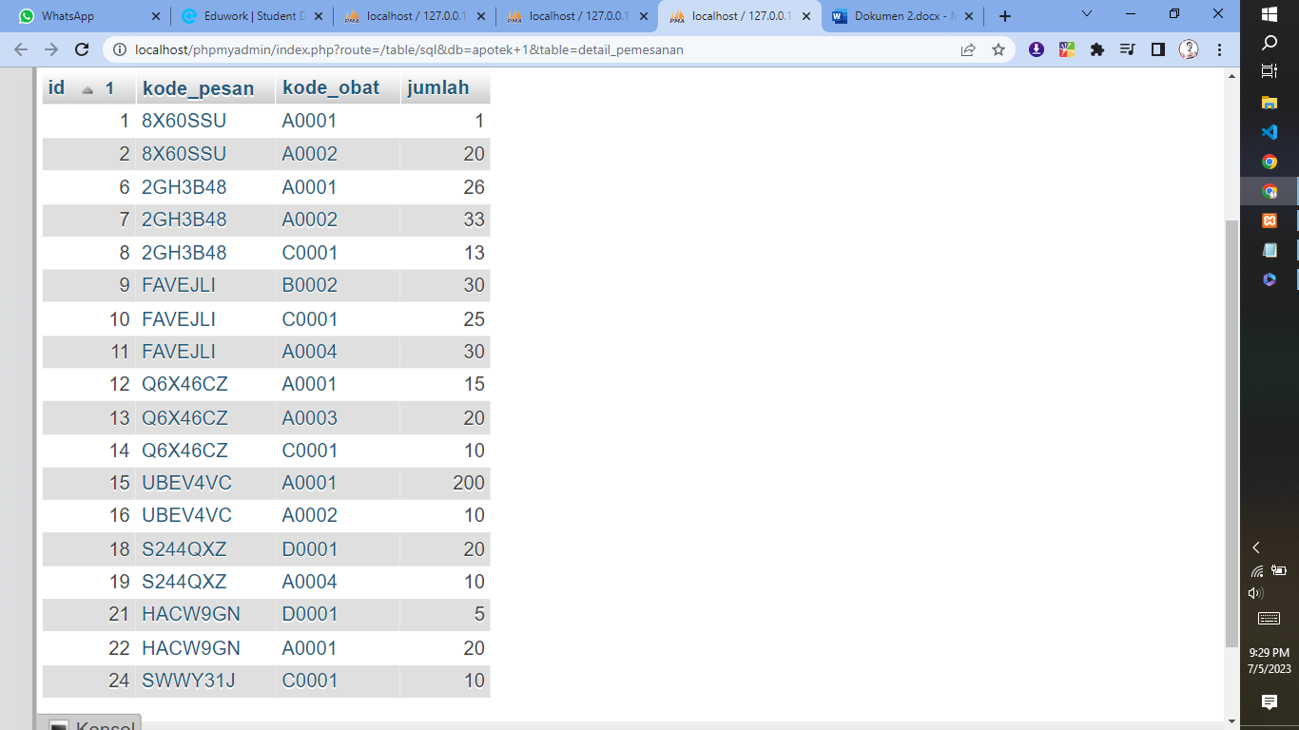
* [SELECT](http://localhost/phpmyadmin/url.php?url=https://dev.mysql.com/doc/refman/8.0/en/select.html) id, kode_pesan, detail_pemesanan.kode_obat, jumlah FROM `detail_pemesanan` [RIGHT](http://localhost/phpmyadmin/url.php?url=https://dev.mysql.com/doc/refman/8.0/en/string-functions.html%23function_right) JOIN obat ON detail_pemesanan.kode_obat = obat.kode_obat ORDER BY id ASC
* 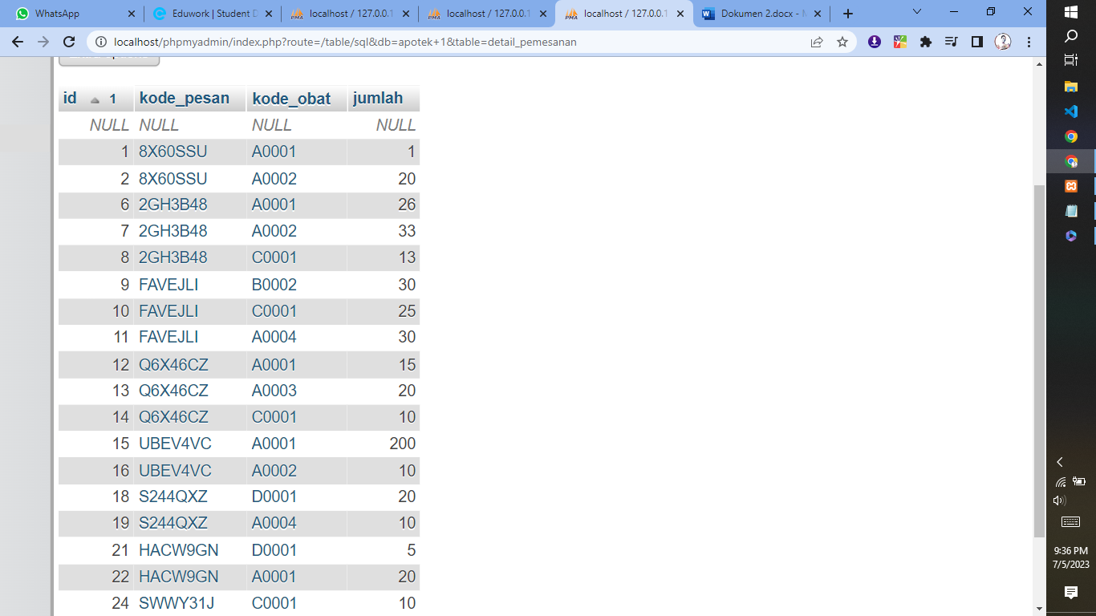
* [SELECT](http://localhost/phpmyadmin/url.php?url=https://dev.mysql.com/doc/refman/8.0/en/select.html) id, kode_pesan, detail_pemesanan.kode_obat, jumlah FROM `detail_pemesanan` [LEFT](http://localhost/phpmyadmin/url.php?url=https://dev.mysql.com/doc/refman/8.0/en/string-functions.html%23function_left) JOIN obat ON detail_pemesanan.kode_obat = obat.kode_obat ORDER BY id ASC;
* 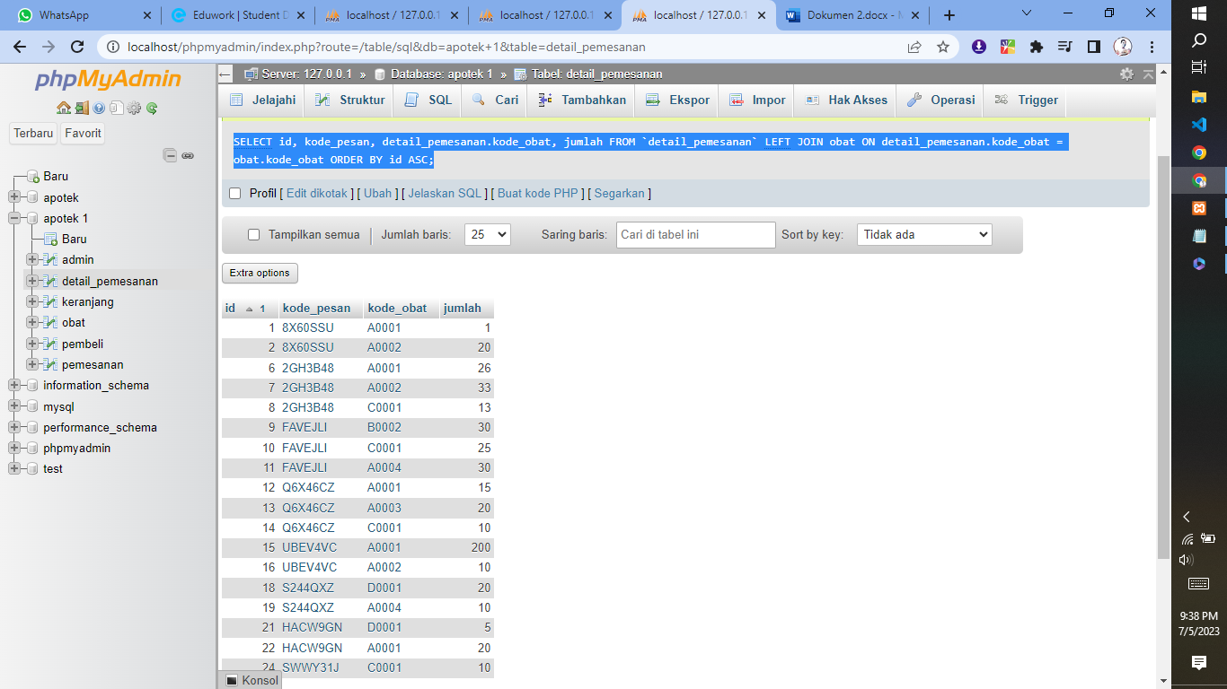
* [SELECT](http://localhost/phpmyadmin/url.php?url=https://dev.mysql.com/doc/refman/8.0/en/select.html) id, kode_pesan, detail_pemesanan.kode_obat, jumlah FROM `detail_pemesanan` JOIN obat ON detail_pemesanan.kode_obat = obat.kode_obat WHERE detail_pemesanan.kode_obat [LIKE](http://localhost/phpmyadmin/url.php?url=https://dev.mysql.com/doc/refman/8.0/en/string-comparison-functions.html%23operator_like) '%A0001%' [AND](http://localhost/phpmyadmin/url.php?url=https://dev.mysql.com/doc/refman/8.0/en/logical-operators.html%23operator_and) jumlah >= 20 ORDER BY id ASC;
* 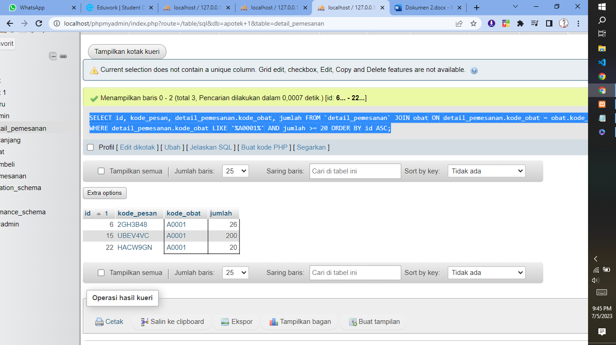
* [SELECT](http://localhost/phpmyadmin/url.php?url=https://dev.mysql.com/doc/refman/8.0/en/select.html) id, kode_pesan, detail_pemesanan.kode_obat, jumlah FROM `detail_pemesanan` JOIN obat ON detail_pemesanan.kode_obat = obat.kode_obat WHERE detail_pemesanan.kode_obat [LIKE](http://localhost/phpmyadmin/url.php?url=https://dev.mysql.com/doc/refman/8.0/en/string-comparison-functions.html%23operator_like) '%C0001%' [AND](http://localhost/phpmyadmin/url.php?url=https://dev.mysql.com/doc/refman/8.0/en/logical-operators.html%23operator_and) jumlah <= 15 ORDER BY id ASC;
* 